**ACTIVITY**

1. **Research why division by zero is not possible [1]. You are expected to figure this out and share relevant videos with the class.**

**1) Mathematical Reasoning**

Division is the inverse of multiplication. For example, 6 ÷ 3 = 2, 6 ÷ 3 = 2, 6 ÷ 3 = 2, because 2 × 3 = 6, 2 × 3 = 6, 2 × 3 = 6.

If we try 6÷0, we are asking: What number multiplied by 0 gives 6?

But any number multiplied by 0 is **0**, never 6. So there’s no answer.

2) **Undefined Result**

If you attempt 0÷0, it becomes even worse.

0 × 1 = 0, 0 × 2 = 0, 0 × 100 = 0. So infinitely many answers could fit.

This makes the expression **indeterminate** (no single value can be assigned).

3) **Practical Example**

Imagine sharing 10 apples among 5 friends: each gets 2.

Sharing 10 apples among 0 friends doesn’t make sense. There’s no one to receive them.

4) **In Calculus and Real-World Math**

Division by zero causes discontinuities (breaks) in functions, which can lead to infinite or undefined values.

That’s why calculators and computers usually give an **error** when you try dividing by 0.

1. **Research electrical appliance frequencies in different countries. You need to investigate the different frequencies (in Hertz) at which electrical appliances operate across various countries. Furthermore, you should understand and explain the reasons behind these frequency differences (e.g., why some countries have higher frequencies and others lower). You are required to share your scripts and findings on the team's channel.**

## **1） Global Overview**

Worldwide, two main frequencies are used: 50 Hz and 60 Hz. Most of Europe, Asia, Africa, and Oceania use 50 Hz, while the Americas use 60 Hz. Japan is unique: 50 Hz in the East and 60 Hz in the West.

Figure 1. Global share of 50 Hz vs 60 Hz

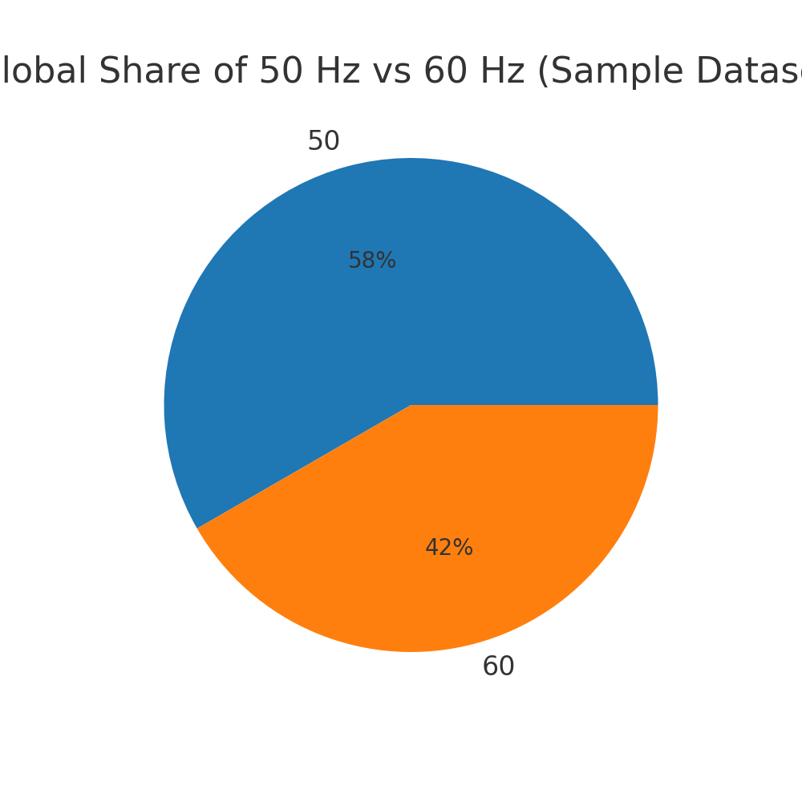

## **2. Regional Distribution**

The following charts illustrate regional patterns: stacked bars compare 50 Hz and 60 Hz within each region, while the horizontal bar highlights regions with the most 50 Hz countries.

Figure 2. 50 Hz vs 60 Hz by region (stacked bar)

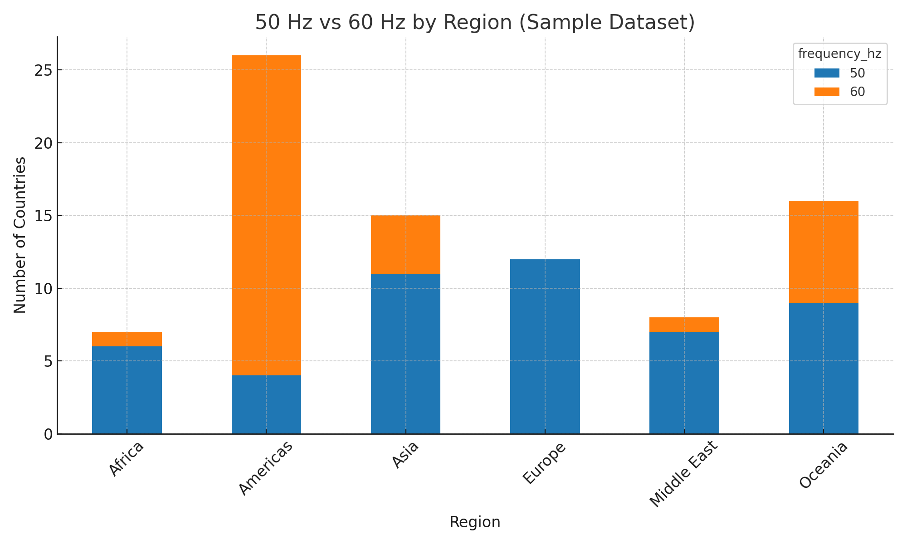

Figure 3. Regions with most 50 Hz countries (horizontal bar)

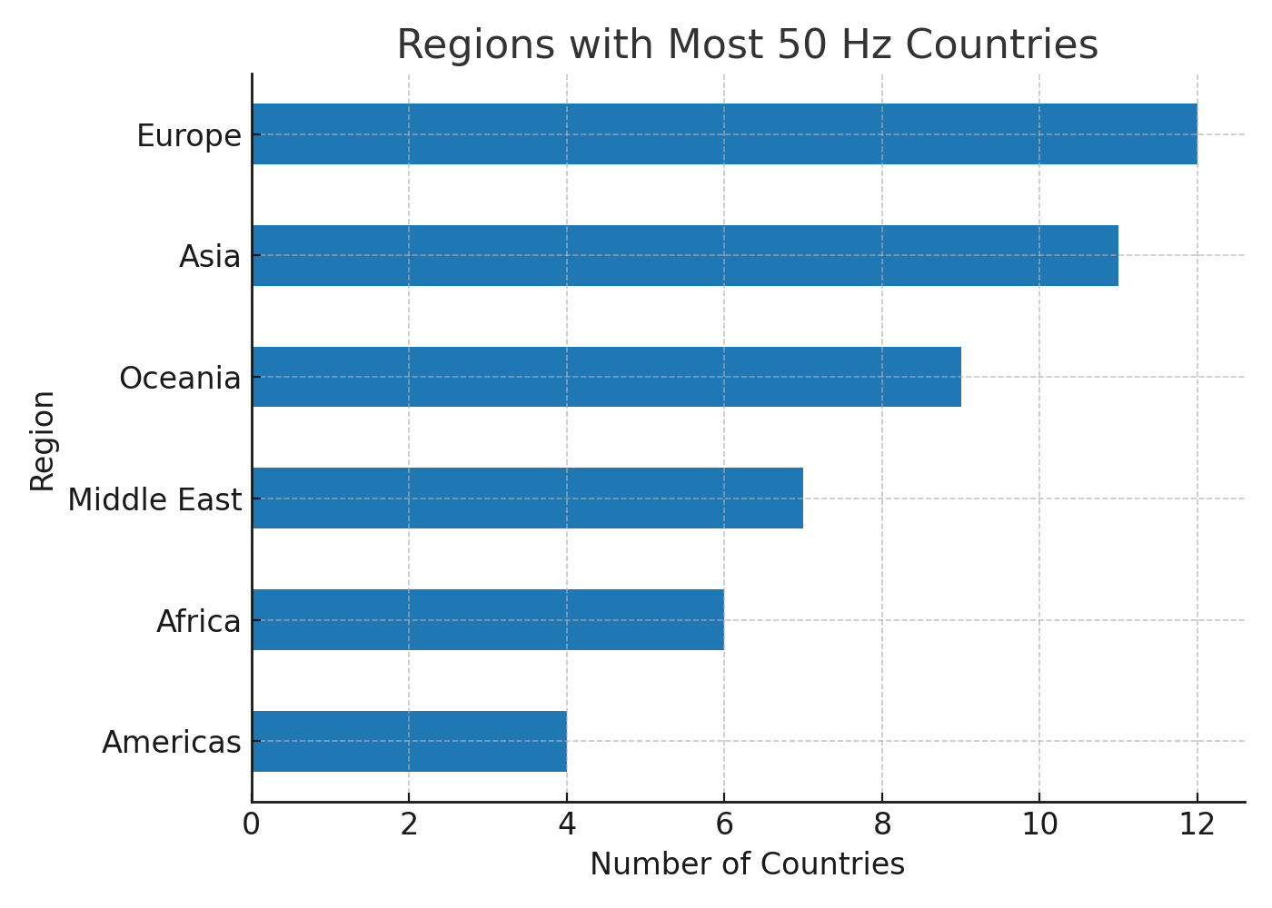

## **3. Why the Difference?**

- History: Europe adopted 50 Hz, North America 60 Hz; Japan imported both.  
- Engineering: 50/60 Hz were compromises between lighting flicker, motor speed, and transformer design.  
- Grid: Each grid must run at one frequency; changing it is very costly.

## **4. Examples**

50 Hz: New Zealand, Australia, China, India, EU  
60 Hz: USA, Canada, Mexico, Brazil  
Mixed: Japan (East 50 Hz, West 60 Hz)  
Special: Jamaica 50 Hz, French Polynesia mostly 60 Hz but Marquesas Islands 50 Hz

## **5. Impact on Devices**

Modern chargers usually accept both 50/60 Hz. Motors and timer-based appliances may not work correctly if used at the wrong frequency.